

**USED CAR PRICE PREDICTION PROJECT**

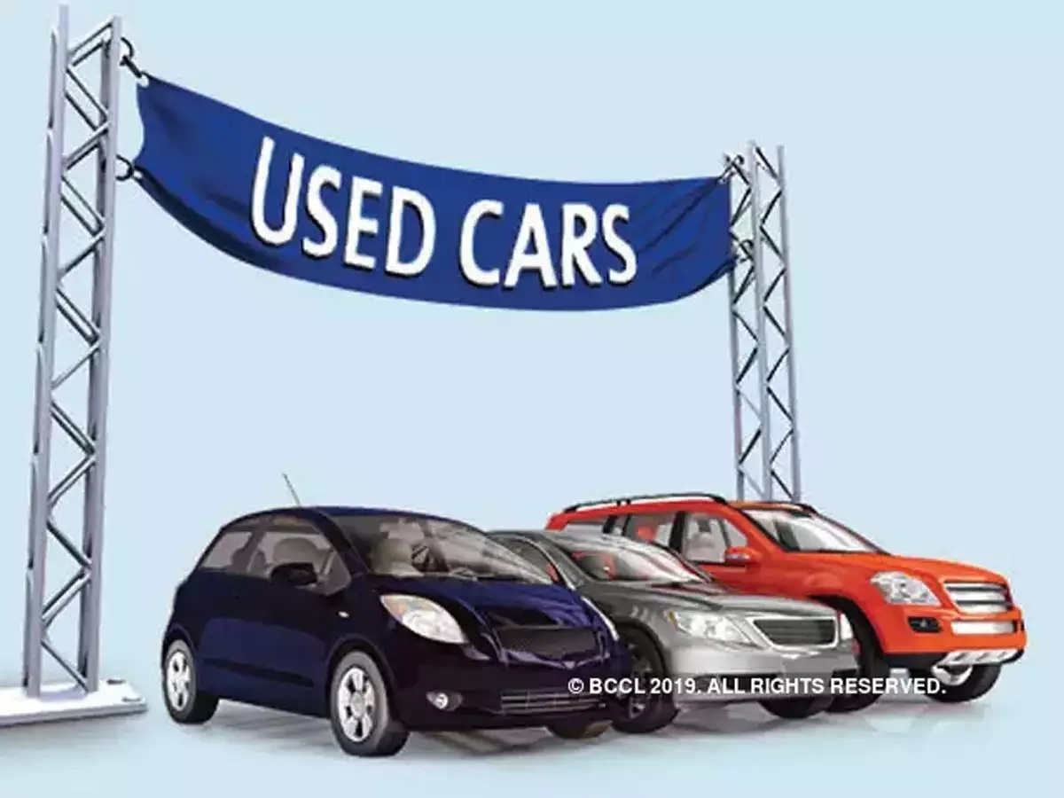

Submitted by: SRI BHARATH VASA

**INTRODUCTION**

* Business Problem Framing

Impact of COVID-19 on Indian automotive sector: The Indian automotive sector was already struggling in FY20. before the Covid-19 crisis. It saw an overall degrowth of nearly 18 per cent. This situation was worsened by the onset of the Covid-19 pandemic and the ongoing lockdowns across India and the rest of the world. These two years (FY20 and FY21) are challenging times for the Indian automotive sector on account of slow economic growth, negative consumer sentiment, BS-VI transition, changes to the axle load norms, liquidity crunch, low-capacity utilisation and potential bankruptcies. The return of daily life and manufacturing activity to near normalcy in China and South Korea, along with extended lockdown in India, gives hope for a U-shaped economic recovery. Our analysis indicates that the Indian automotive sector will start to see recovery in the third quarter of FY21. We expect the industry demand to be down 15-25 per cent in FY21. With such degrowth, OEMs, dealers and suppliers with strong cash reserves and better access to capital will be better positioned to sail through. Auto sector has been under pressure due to a mix of demand and supply factors. However, there are also some positive outcomes, which we shall look at.

• With India’s GDP growth rate for FY21 being downgraded from 5% to 0% and later to (-5%), the auto sector will take a hit. Auto demand is highly sensitive to job creation and income levels and both have been impacted. CII has estimated the revenue impact at $2 billion on a monthly basis across the auto industry in India.

• Supply chain could be the worst affected. Even as China recovers, supply chain disruptions are likely to last for some more time. The problems on the Indo-China border at Ladakh are not helping matters. Domestic suppliers are chipping in but they will face an inventory surplus as demand remains tepid.

• The Unlock 1.0 will coincide with the implementation of the BS-VI norms and that would mean heavier discounts to dealers and also to customers. Even as auto companies are managing costs, the impact of discounts on profitability is going to be fairly steep.

• The real pain could be on the dealer end with most of them struggling with excess inventory and lack of funding options in the post COVID-19 scenario. The BS-VI price increases are also likely to hit auto demand. There are two positive developments emanating from COVID-19. The China supply chain shock is forcing major investments in the “Make in India” initiative. The COVID-19 crisis has exposed chinks in the automobile business model and it could catalyse a big move towards electric vehicles (EVs). That could be the big positive for auto sector.

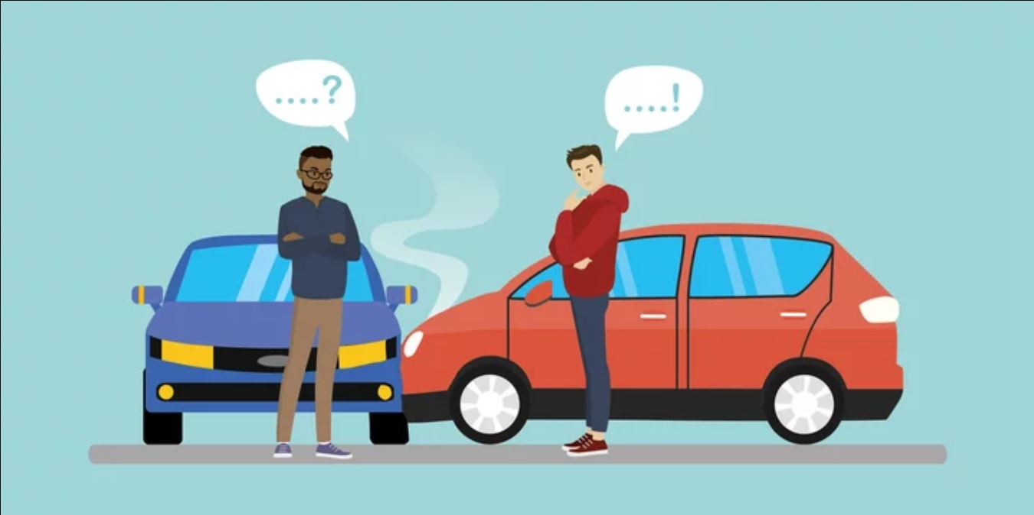

* Conceptual Background of the Domain Problem

The growing world of e-commerce is not just restricted to buying electronics and clothing but everything that you expect in a general store. Keeping the general store perspective aside and looking at the bigger picture, every day there are thousands or perhaps millions of deals happening in the digital marketplace. One of the most booming markets in the digital space is that of the automobile industry wherein the buying and selling of used cars take place. Sometimes we need to walk up to the dealer or individual sellers to get a used car price quote. However, buyers and sellers face a major stumbling block when it comes to their used car valuation or say their second-hand car valuation. Traditionally, you would go to a showroom and get your vehicle inspected before learning about the price. So instead of doing all these stuffs we can build a machine learning model using different features of the used cars to predict the exact and valuable car price.

* Review of Literature

This project is more about exploration, feature engineering and classification that can be done on this data. Since we scrape huge amount of data that includes more car related features, we can do better data exploration and derive some interesting features using the available columns.

The goal of this project is to build an application which can predict the car prices with the help of other features. In the long term, this would allow people to better explain and reviewing their purchase with each other in this increasingly digital world.

* Motivation for the Problem Undertaken

Based on the problem statement and the real time data scrapped from the OLX and Cars24 websites, I have understood how each independent feature helped me to understand the data as each feature provides a different kind of information. It is so interesting to work with different types of real time data in a single data set and perform root cause analysis to predict the price of the used car. Based on the analysis of the model of the car, kilometres driven, transmission type, fuel type etc. I would be able to model the price of used car as this model will then be used by the client to understand how exactly the prices vary with the variables. They can accordingly work on it and make some strategies to sell the used car and get some high returns. Furthermore, the model will be a good way for the client to understand the pricing dynamics of a used car.

**Analytical Problem Framing**

* Mathematical/ Analytical Modeling of the Problem

In our scrapped dataset, our target variable "Used Car Price " is a continuous variable. Therefore, we will be handling this modelling problem as regression.

This project is done in two parts:

* Data Collection phase
* Model Building phase

Data Collection phase:

You have to scrape at least 5000 used cars data. You can scrape more data as well, it’s up to you. More the data better the model. In this section You need to scrape the data of used cars from websites (OLX, OLA, Car Dekho, Cars24 etc.) You need web scraping for this. You have to fetch data for different locations. The number of columns for data doesn’t have limit, it’s up to you and your creativity. Generally, these columns are Brand, model, variant, manufacturing year, driven kilometres, fuel, number of owners, location and at last target variable Price of the car. This data is to give you a hint about important variables in used car model. You can make changes to it, you can add or you can remove some columns, it completely depends on the website from which you are fetching the data. Try to include all types of cars in your data for example- SUV, Sedans, Coupe, minivan, Hatchback.

Model Building phase:

After collecting the data, you need to build a machine learning model. Before model building do all data pre-processing steps. Try different models with different hyper parameters and select the best model. Follow the complete life cycle of data science. Include all the below steps mentioned:

1. Data Cleaning

2. Exploratory Data Analysis (EDA)

3. Data Pre-processing and Visualisation

4. Model Building

5. Model Evaluation

6. Selecting the best model

* Data Sources and their formats

The dataset is in the form of CSV (Comma Separated Value) format and consists of 6 columns (5 features and 1 label) with 10000 number of records as explained below:

* Used Car Model - This shows the car model names
* Year of Manufacture - Gives us the year in which the car was made
* Kilometres Driven - Number of kilometres the car the driven reflecting on the Odometer
* Fuel Type - Shows the fuel type used by the vehicle
* Transmission Type - Gives us the manual or automatic gear shifting mechanism
* Used Car Price - Lists the selling price of the used cars

We can see our dataset includes a target label "Used Car Price" column and the remaining feature columns can be used to determine or help in predicting the price of the used cars. Since price is a continuous value it makes this to be a Regression problem!

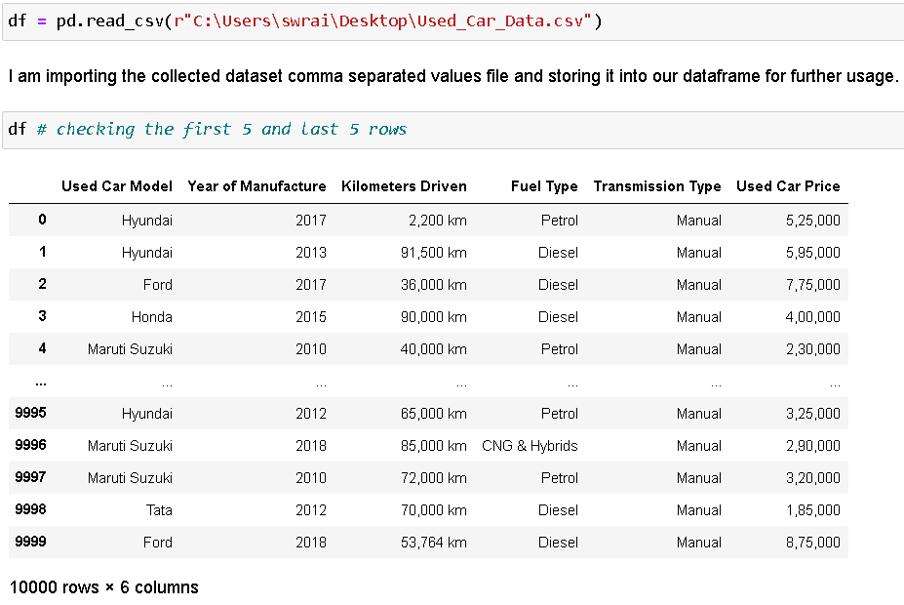

* Data Preprocessing Done

For the data pre-processing step, I checked through the dataframe for missing values, imputed records with “-“ using various imputing techniques to handle them.

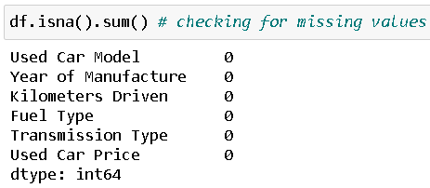

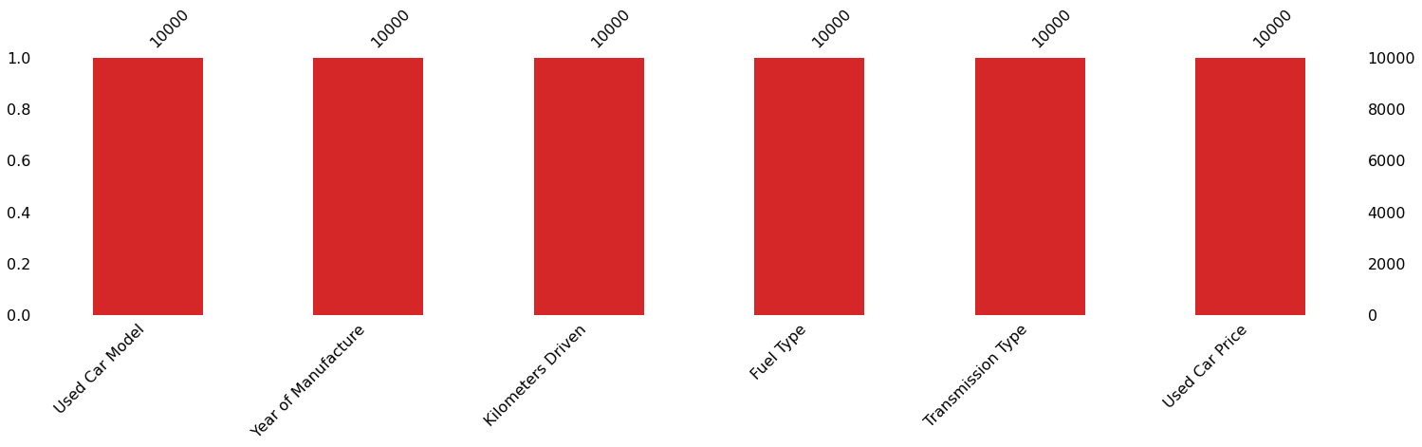

Checked the datatype details for each column to understand the numeric ones and its further conversion process.

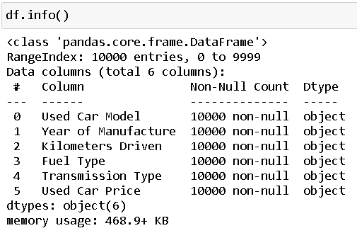

I also took a look at all the unique value present in each of the columns and then decided to dealt with the imputation part accordingly.

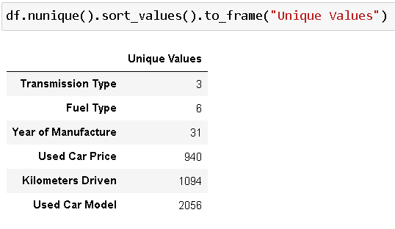

The various data imputation performed on our data set are shown below with the code.

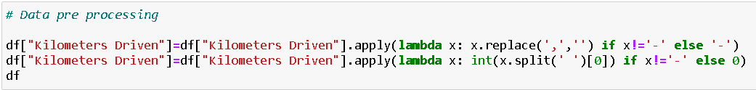

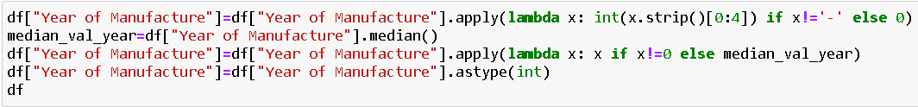

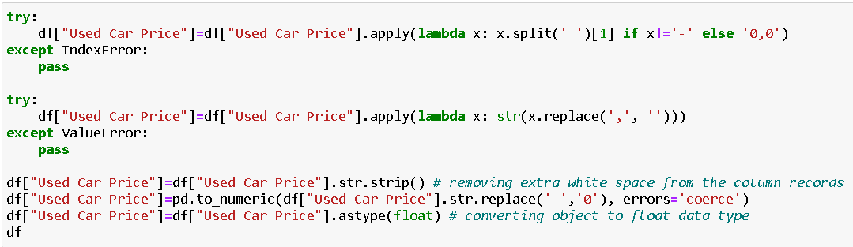

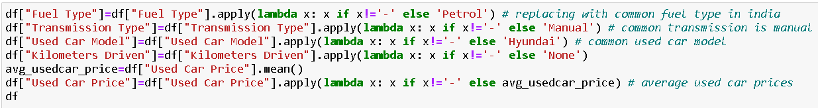

I then used the “describe” method to check the count, mean, standard deviation, minimum, maximum, 25%, 50% and 75% quartile data.

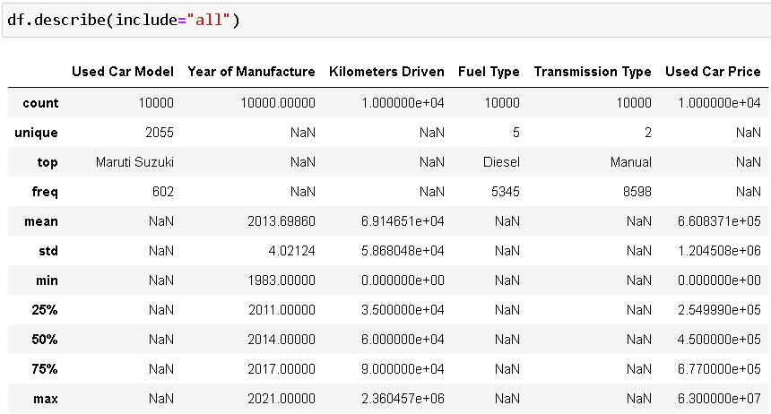

Took a visual on just the numeric part as well and saw just the maximum value for Used Car Price column at a higher scale.

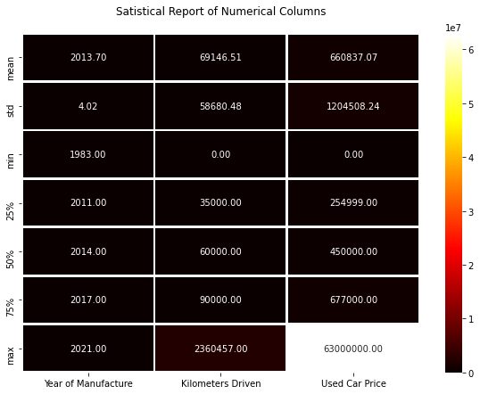

* Data Inputs- Logic- Output Relationships

The input data were initially all object datatype so had to clean the data by removing unwanted information like “km” from Kilometres Driven column and ensuring the numeric data are converted accordingly. I then used Ordinal Encoding method to convert all the categorical feature columns to numeric format.

Code:

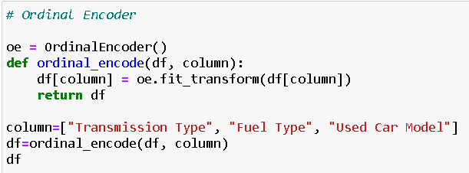

Made use of Z score method to remove outliers that were present on our dataset.

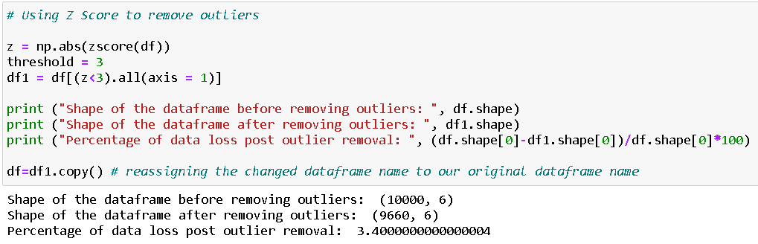

To handle the skewness, I made use of Log transformation technique ensuring that at least a bell shape curve closer to normal distribution is achieved.

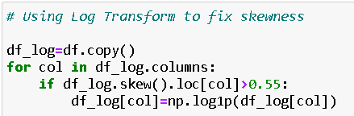

* Hardware and Software Requirements and Tools Used

Hardware technology being used.

RAM : 12 GB

CPU : Intel core i5 11th generation 2.40 GHz

GPU : Intel iRIS Xe Graphics Card

Software technology being used.

Programming language : Python

Distribution : Anaconda Navigator

Browser based language shell : Jupyter Notebook

Libraries/Packages specifically being used.

Pandas, NumPy, matplotlib, seaborn, scikit-learn, pandas-profiling, missingno

**Model/s Development and Evaluation**

* Identification of possible problem-solving approaches (methods)

1. Clean the dataset from unwanted scraped details.
2. Impute missing values with meaningful information.
3. Encoding the categorical data to get numerical input data.
4. Compare different models and identify the suitable model.
5. R2 score is used as the primary evaluation metric.
6. MSE and RMSE are used as secondary metrics.
7. Cross Validation Score was used to ensure there are no overfitting our underfitting models.

* Testing of Identified Approaches (Algorithms)

Libraries and Machine Learning Regression models that were used in this project are shown below.

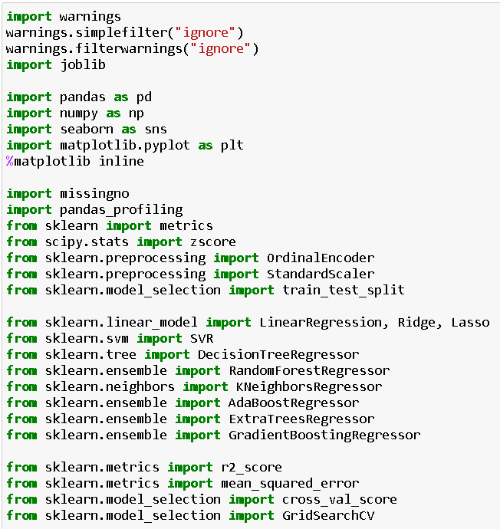

All the regression machine learning algorithms used are:

* Linear Regression Model
* Ridge Regularization Model
* Lasso Regularization Model
* Support Vector Regression Model
* Decision Tree Regression Model
* Random Forest Regression Model
* K Neighbours Regression Model
* Gradient Boosting Regression Model
* Ada Boost Regression Model
* Extra Trees Regression Model
* Run and Evaluate selected models

I created a Regression Machine Leaning Model function incorporating the evaluation metrics so that we can get the required data for all the above models.

Code:

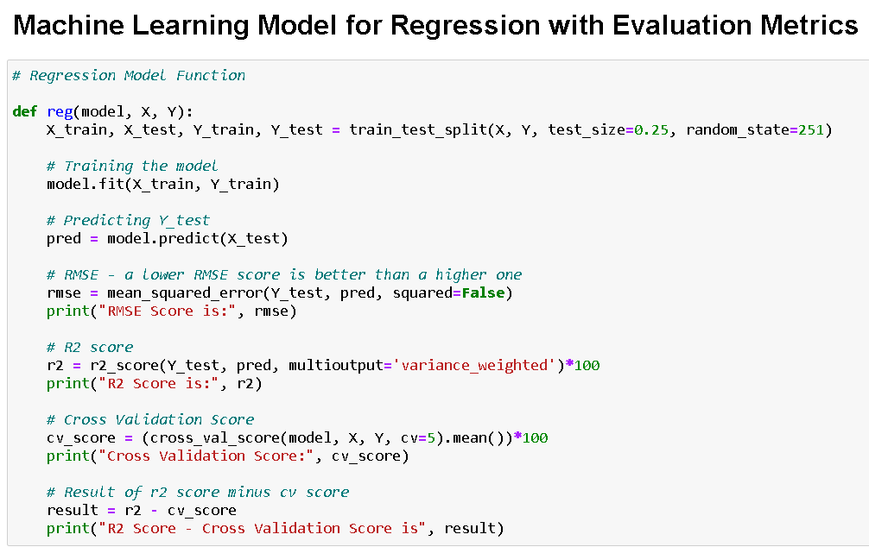

Output:



* Key Metrics for success in solving problem under consideration

RMSE Score:

Root Mean Square Error (RMSE) is the standard deviation of the residuals (prediction errors). Residuals are a measure of how far from the regression line data points are; RMSE is a measure of how spread out these residuals are. In other words, it tells you how concentrated the data is around the line of best fit.

R2 Score:

The R2 score is a very important metric that is used to evaluate the performance of a regression-based machine learning model. It is pronounced as R squared and is also known as the coefficient of determination. It works by measuring the amount of variance in the predictions explained by the dataset.

Cross Validation Score:

Cross-validation is a statistical method used to estimate the skill of machine learning models. It is commonly used in applied machine learning to compare and select a model for a given predictive modelling problem because it is easy to understand, easy to implement, and results in skill estimates that generally have a lower bias than other methods. The k-fold cross validation is a procedure used to estimate the skill of the model on new data. There are common tactics that you can use to select the value of k for your dataset (I have used 5-fold validation in this project). There are commonly used variations on cross-validation such as stratified and repeated that are available in scikit-learn.

Hyper Parameter Tuning:

In machine learning, hyperparameter optimization or tuning is the problem of choosing a set of optimal hyperparameters for a learning algorithm. A hyperparameter is a parameter whose value is used to control the learning process. By contrast, the values of other parameters (typically node weights) are learned.

Code:

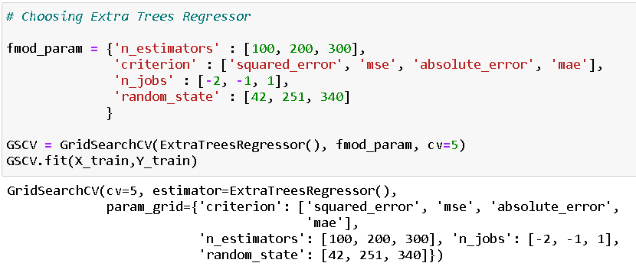

Final model score after plugging in the best parameter values:

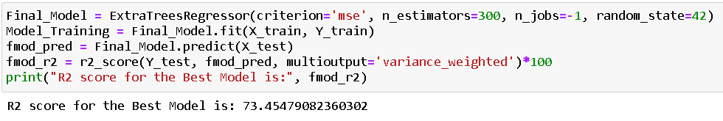

* Visualizations

I used the pandas profiling feature to generate an initial detailed report on my dataframe values. It gives us various information on the rendered dataset like the correlations, missing values, duplicate rows, variable types, memory size etc. This assists us in further detailed visualization separating each part one by one comparing and research for the impacts on the prediction of our target label from all the available feature columns.

Code:

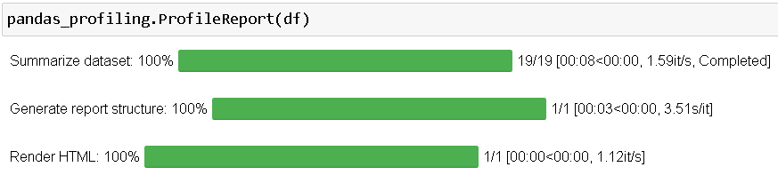

Output:

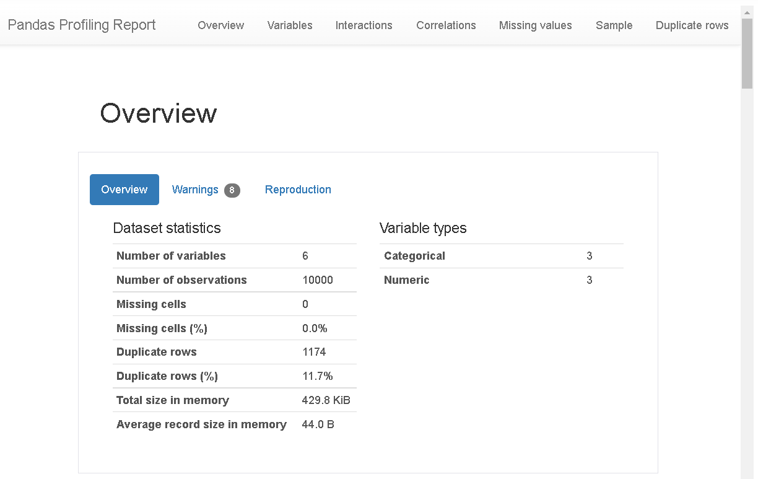

pandas-profiling is an open-source Python module with which we can quickly do an exploratory data analysis with just a few lines of code. It generates interactive reports in web format that can be presented to any person, even if they don’t know programming. It also offers report generation for the dataset with lots of features and customizations for the report generated. In short, what pandas-profiling does is save us all the work of visualizing and understanding the distribution of each variable. It generates a report with all the information easily available.

I generated count plots, bar plots, pair plots, heatmap and others to visualise the datapoint present in our column records.

Code:

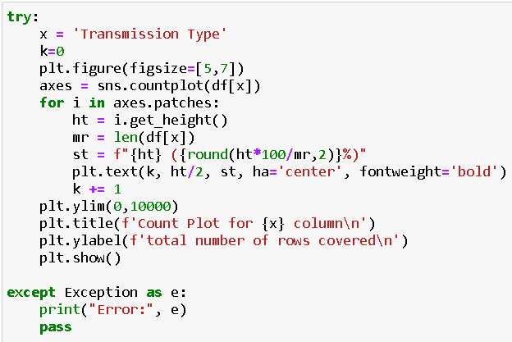

Output:



Code:

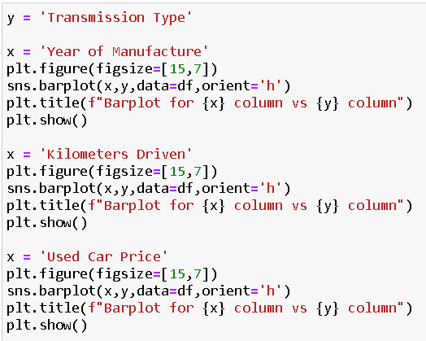

Output:



Code:

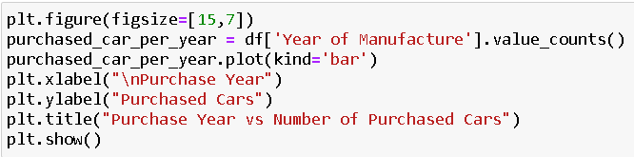

Output:

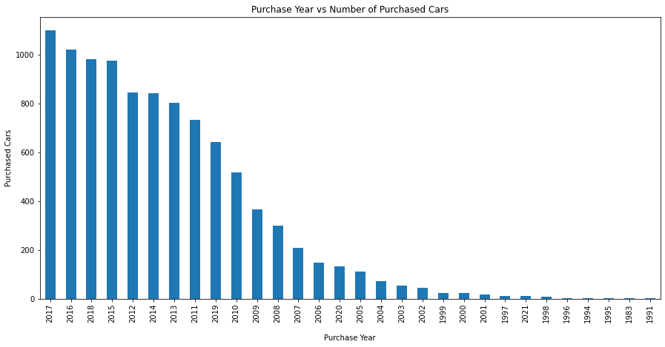

Code:

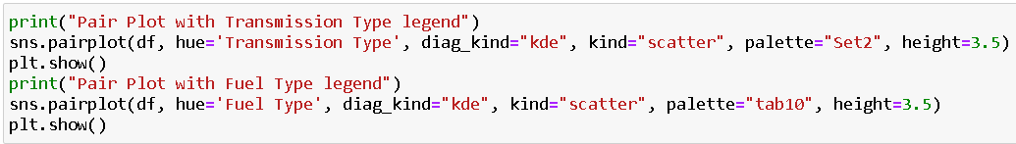

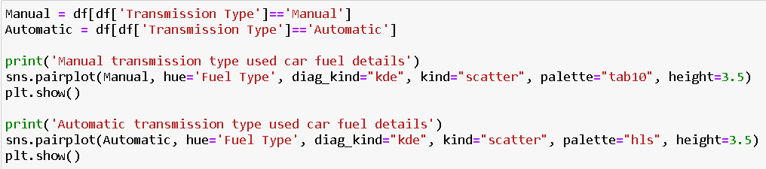

Output:



Code:

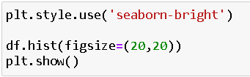

Output:

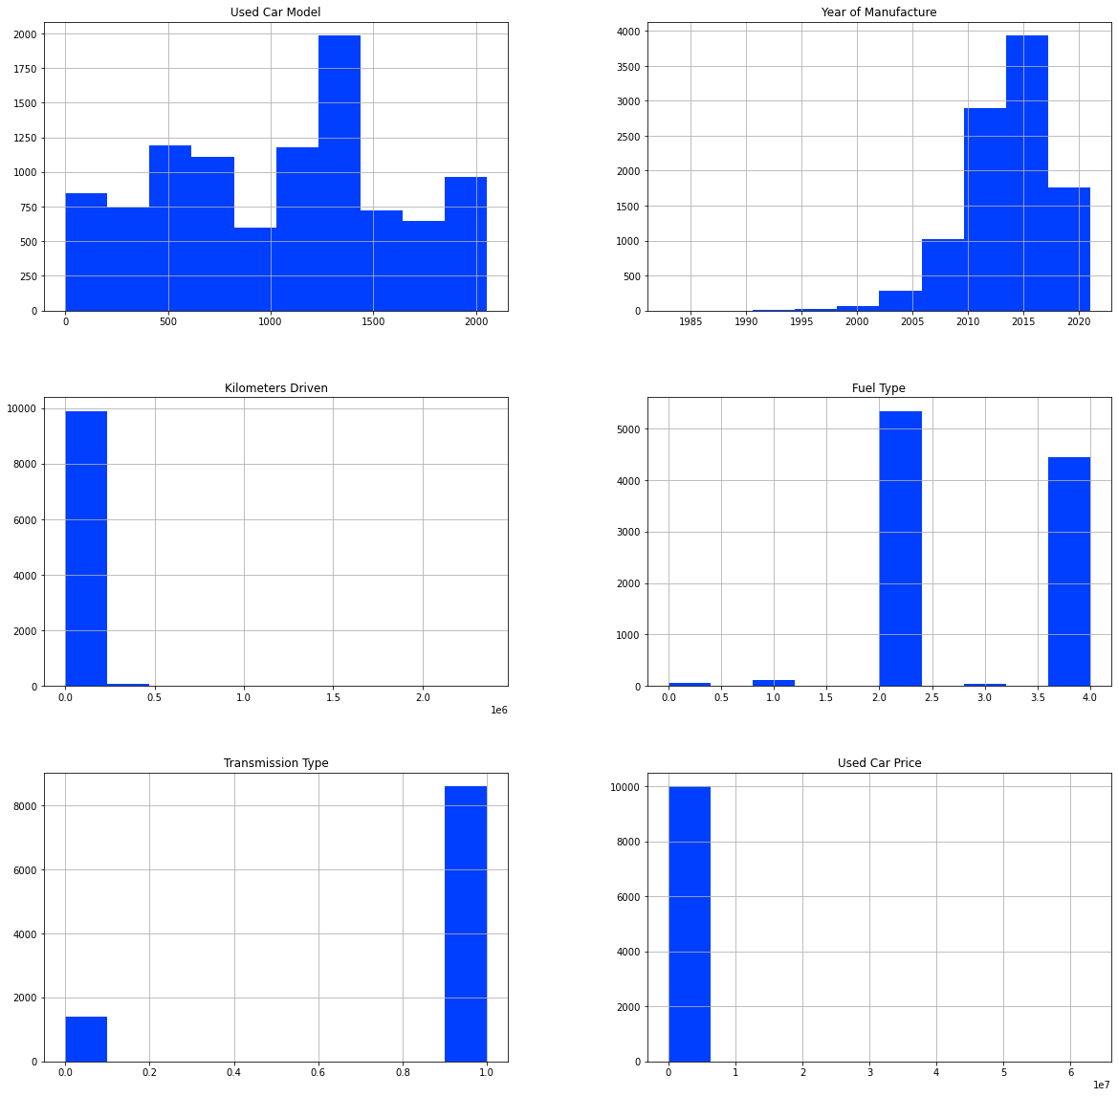

Code:

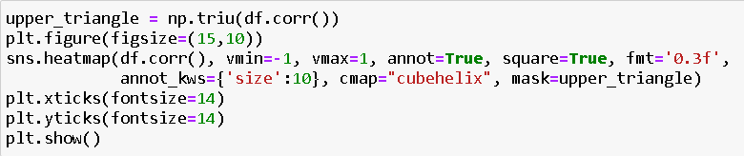

Output:

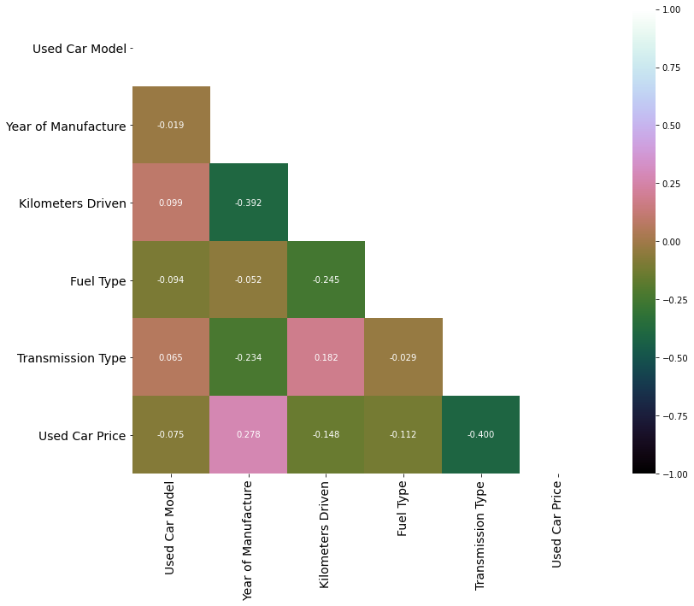

Code:

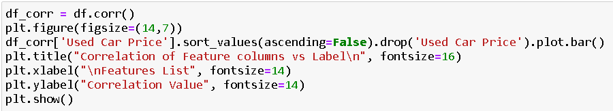

Output:

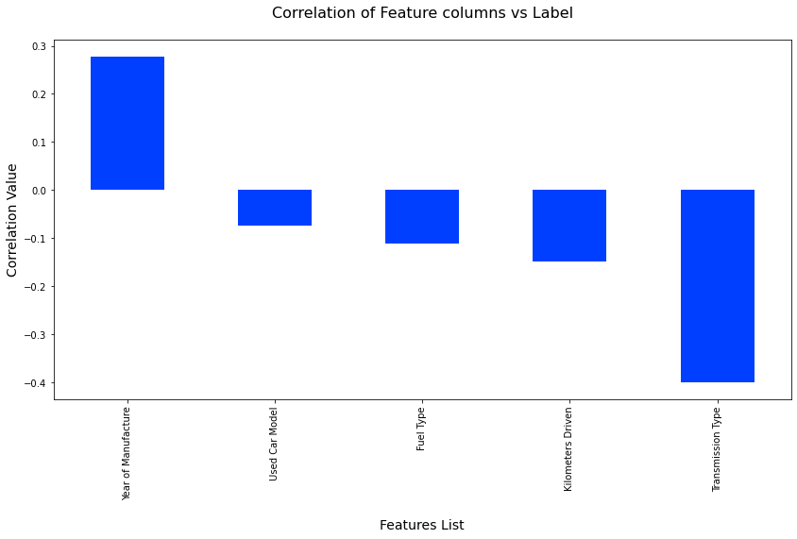

Outliers and Skewness before and after treating them:





Code:

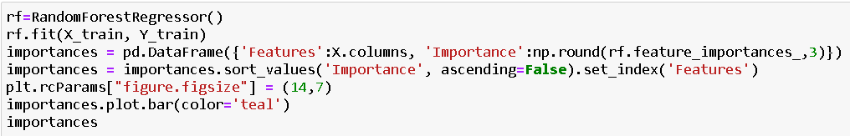

Output:

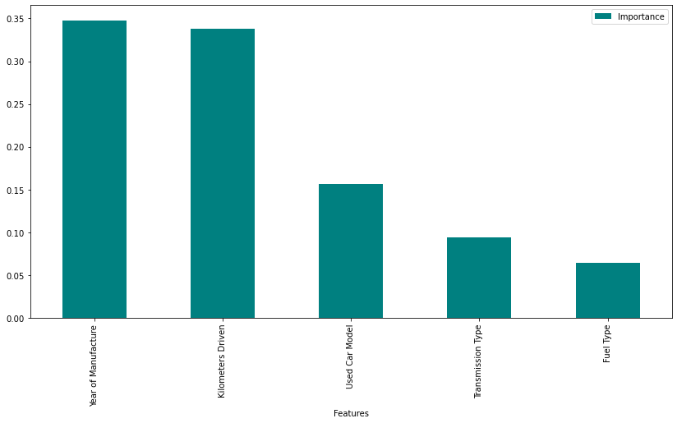

* Interpretation of the Results

We can see from the visuals that the features are impacting the price of used cars. There were categorical columns which I encoded using the ordinal encoder method instead of the one hot encoding to avoid the generation of large number of columns. Also, I our target label stored continuous numeric data and therefore label encoder was out of the picture to be used.

**CONCLUSION**

* Key Findings and Conclusions of the Study

After the completion of this project, we got an insight on how to collect data, pre-processing the data, analysing the data and building a model. First, we collected the used cars data from different websites like OLX, Car Dekho, Cars 24, OLA etc and it was done by using Web Scraping. The framework used for web scraping was Beautiful Soup and Selenium, which has an advantage of automating our process of collecting data. We collected almost 10000 of data which contained the selling price and other related features of used cars. Then the scrapped data was combined in a single data frame and saved in a csv file so that we can open it and analyse the data. We did data cleaning, data pre-processing steps like finding and handling null values, removing words from numbers, converting object to int type, data visualization, handling outliers and skewness etc. After separating our train and test data, we started running different machine learning regression algorithms to find out the best performing model. We found that Extra Tree Regressor Algorithm was performing well according to their r2_score and cross validation scores. Then we performed Hyperparameter Tuning technique using Grid Search CV for getting the best parameters and improving the score. In that Extra Tree Regressor Algorithm did not perform quite well as previously on the defaults but we finalised that model for further predictions as it was still better than the rest. We saved the final model in pkl format using the joblib library after getting a dataframe of predicted and actual used car price details.

* Learning Outcomes of the Study in respect of Data Science

Visualization part helped me to understand the data as it provides graphical representation of huge data. It assisted me to understand the feature importance, outliers/skewness detection and to compare the independent-dependent features. Data cleaning is the most important part of model building and therefore before model building, I made sure the data is cleaned and scaled. I have generated multiple regression machine learning models to get the best model wherein I found Extra Trees Regressor Model being the best based on the metrics I have used.

* Limitations of this work and Scope for Future Work

The limitations we faced during this project were:

The website was poorly designed because the scrapping took a lot of time and there were many issues in accessing to next page. Also need further practise in terms of various web scraping techniques. More negative correlated data were present than the positive correlated one's. Presence of outliers and skewness were detected and while dealing with them we had to lose a bit of valuable data. No information for handling these fast-paced websites were provided so that was consuming more time in web scraping part.

Future Work Scope:

Current model is limited to used car data but this can further be improved for other sectors of automobiles by training the model accordingly. The overall score can also be improved further by training the model with more specific data.